

Faculty of Engineering and Technology

Electrical and Computer Engineering Department

Communications Laboratory

**Report #2:**

**Experiment No 6: Pulse Amplitude Modulation (Sampling)**

Prepared by

Arwa Doha - 1190324

Instructor

Dr.Ashraf Al-Rimawi

Assistant

Eng.Mohammad Al-Battat

BIRZEIT

December – 2023

**Abstract**

The*aim*of*this*experiment*is*to*understand*the*Pulse*Amplitude*Modulation and*how*sampling*works*for*specific*sampling*frequencies. We experiment with two types of*sampling*and*discuss*their*differences.**Moreover,*we*show*the*modulation*and demodulation*of*various*signals*in*both*the*frequency*domain*and*time*domain*and discuss*the results in comparison*with the*theoretical part. Also, we compare*signals*that* have* aliasing*with non-aliasing signals, and*we discuss*the*importance of*time*multiplexing and its challenges.

Table of Contents

**Abstract** 1

**Theory** 4

**2.1 Pulse-Amplitude-Modulation-(PAM)-and-Sampling-Techniques** 4

**2.2 Demodulation/Aliasing /and /Nyquist /Rate.** 5

**2.3 Pulse Amplitude Modulation//Time//Multiplexing//and//Crosstalk**. 6

**Procedure$and$Data**$**Analysis** 7

**3.1 Time/and/Frequency//Characteristics/of/.pulse/train** 7

**3.2 Characteristics of Pulse Amplitude Modulation (PAM).** 10

**3.3 Characteristics of Pulse Amplitude Demodulation.** 21

**3.4 Aliasing in the Time and the Frequency Domain.** 23

**3.5 PAM Time Multiplex**. 26

**Conclusion** 29

**References** 30

**Table of Figures**

* Figure 1: Pulse amplitude modulation Signal 5
* Figure 2: Natural-/Sampling 6
* Figure 3: Flat//top-/PAM 6
* Figure 4: Aliased &iiNon-Aliased Signals 7
* Figure 5: Setup/of PAM 8
* Figure 6: Pulse..Train..with..10% Duty Cycle (In Time Domain) 9
* Figure 7: Puls..Train..with..10% Duty Cycle. (In Frequency Domain) 9
* Figure 8: Pulse..Train..with..10% Duty Cycle (In Time Domain) 10
* Figure 9: Pulse/Train/with/30% Duty Cycle. (In Frequency Domain). 11
* Figure 10: Setup of /Pulse/amplitude/modulation 11
* Figure 11: Pulse*frequencies set at/5kHz &/15kHz 12
* Figure 12: Signal*before*and*after the*channel filter 12
* Figure 13: Signal of Pulse amplitude modulated(PAM) 13
* Figure 14: PAM/signal/with/minimum/duty/cycle 14
* Figure 15: PAM1.output.and.clock.generator 14
* Figure 16: Message*signal/with/frequency = 1khz 15
* Figure 17: Message/signal/with/frequency= 2khz 15
* Figure 18: MessageJsignalKwithKDutyKCycle: 10% 16
* Figure 19: MessagehsignalmwithjDutykCycle 30% 16
* Figure 20: Message*signal*with*Duty*Cycle 50% 17
* Figure 21: PAM2,modulated,signal,with,max,duty,cycle. 17
* Figure 22: PAM2/with/minimum/duty/cycle 18
* Figure 23: PAM2/with/maximum/duty/cycle/in/frequency/domain 18
* Figure 24: PAM2*signal.with.message.frequency= 1khz 19
* Figure 25: PAM2*signalcwith1message2frequency = 2khz 19
* Figure 26: PAM2*with-duty-cycle 10% & fm= 500hz 20
* Figure 27: PAM2*with-dutygcycle= 30% & fm= 500hz 20
* Figure 28: PAM2*with/duty/cycle= 50% & fm= 500hz

17

* Figure 29: Demodulated signal 21
* Figure 30: Demodulated signal with 10% duty cycle 32
* Figure 31: Demodulated signal with 30% duty cycle. 32
* Figure 32: Signal with PAM1*modulator 24
* Figure 33: Signal/with/Aliasing 25
* Figure 34: Signal/with/demodulator/filter of CH1 26
* Figure 35: Demodulated signal in frequency domain 26
* Figure 36: PAM,Time,Multiplex*Setup 27
* Figure 37: Triangular,message,channel,CH1 27
* Figure 38: Sine.message channel CH1 28
* Figure 39: Demodulated Signals 28
* Figure 40: Effect.of.delta t.(middle) 29

# **Theory**

**2.1 Pulse-Amplitude-Modulation-(PAM)-and-Sampling-Techniques**

Pulse amplitude modulation (PAM) operates as a modulation technique where the amplitude of the pulsating carrier signal adjusts based on the immediate value of the message signal. This bears resemblance to the amplitude modulation we previously discussed; however, in this case, the carrier isn't continuous but instead manifests as a sequence of rectangular pulses. Pulse amplitude modulation involves the discrete sampling of the analog modulating signal, with each signal being sampled at consistent intervals. During sampling, the continuous-time signal undergoes a transformation into a discrete-time signal while maintaining continuous amplitude. This initial stage stands as the primary step in transitioning a signal from an analog to a digital format[1].

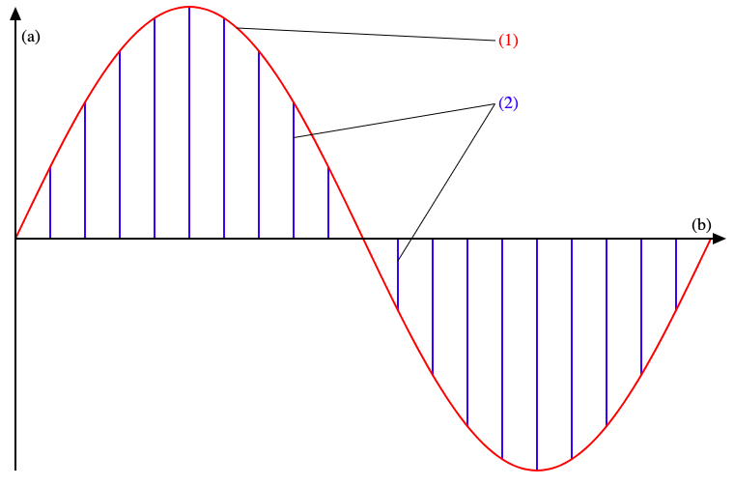

Figure 1: Pulse amplitude modulation Signal

As figure above, presented in blue color, the amplitude of every sample correlates directly with the message signal represented in red color.

Three sampling techniques exist: flat-top sampling, natural sampling, and ideal sampling. Practically unattainable, ideal sampling leads us to employ both flat-top and natural sampling methods within our laboratory. Natural Pulse Amplitude Modulation (PAM) involves the multiplication of an analog signal with an impulse train. The depicted figure 2 showcases the resulting image where the upper segment of the pulses aligns with the modulating wave. Flat-topped PAM finds extensive application due to its ability to eliminate noise-induced distortions during signal transmission, a common issue in Natural PAM. Figure 3 illustrates the flat tops of the samples, highlighting the distinctive feature of this modulation technique.[2][3]

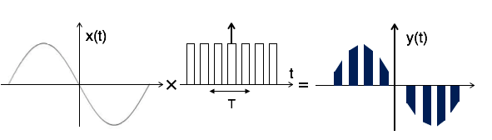

Figure 2: Natural-/Sampling

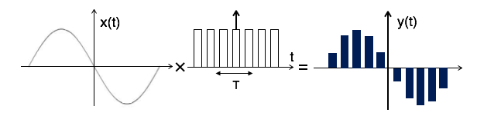

Figure 3: Flat//top-/PAM

The duty cycle quantifies the proportion of time within a cycle that a wave remains in the ON-state. It's computed by dividing the ON-state duration (PW: Pulse width) by the signal's period(Tc). For instance, a 70% duty cycle signifies that the signal remains ON for 70% of the cycle and OFF for the remaining 30%.



**2.2 Demodulation/Aliasing /and /Nyquist /Rate.**

To successfully convert a continuous signal into a sampled one, the sampling frequency should be at least twice the frequency of the message signal to properly retrieve the message signal. The sampling frequency serves as the minimum rate necessary for distortion-free sampling, preventing aliasing and enabling accurate reconstruction of the message signal. For proper reconstruction of the message signal, a crucial condition must be met by ensuring the following equation holds true[3].



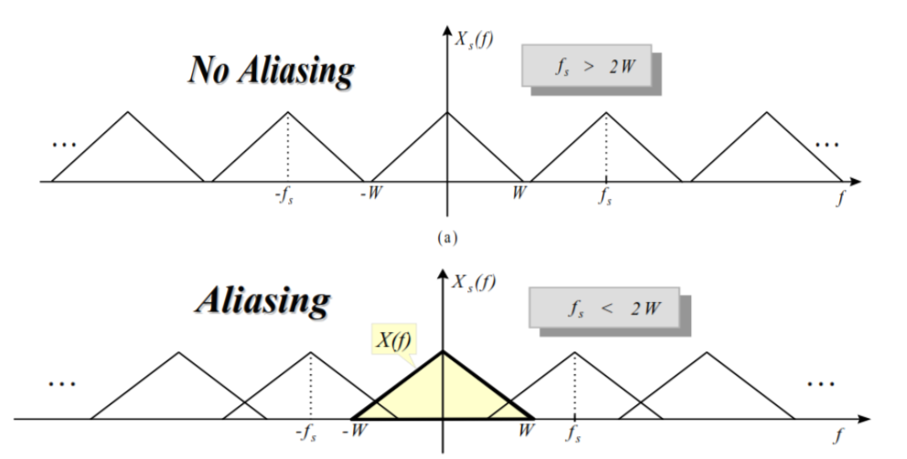

Figure 4: Aliased &iiNon-Aliased Signals

As depicted in the preceding figure, the region where overlap occurs due to undersampling signifies the presence of aliasing effects. Upon confirming the absence of aliasing, the signal undergoes processing through a low-pass filter, facilitating the retrieval of the original message signal.

**2.3 Pulse Amplitude Modulation//Time//Multiplexing//and//Crosstalk**.

Multiplexing involves transmitting multiple data signals through a shared communication channel, assigning distinct time slots within the overall time frame for each signal. Ensuring synchronization is critical, allowing each source to transmit solely during its allocated time slot to prevent collisions. Synchronization problems or constraints in channel bandwidth may lead to cross talk, resulting in noise interference [4].

# **Procedure$and$Data**$**Analysis**

**3.1 Time/and/Frequency//Characteristics/of/.pulse/train**

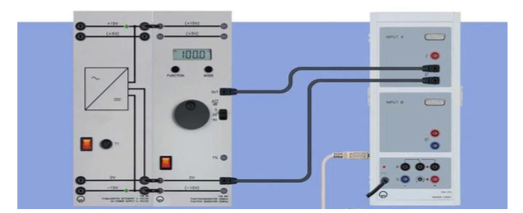

Figure 5: Setup/of PAM

First Initially, we assembled the components and established wire connections following the configuration illustrated in the preceding figure. Using the function generator, we selected a pulse train set at 1 kHz frequency, Vss set to 10V, and with a 10% duty cycle.

This configuration enables us to generate a specific waveform characterized by its frequency, voltage amplitude, and the duration of its active state within each cycle. Adjusting these parameters allows for controlled signal output, crucial for various experiments in signal processing and modulation studies.

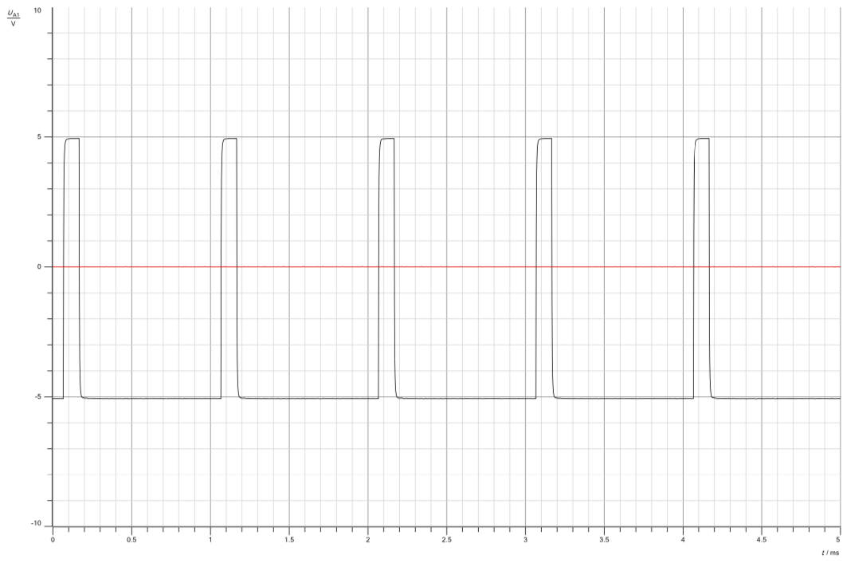

Figure 6: Pulse..Train..with..10% Duty Cycle (In Time Domain)

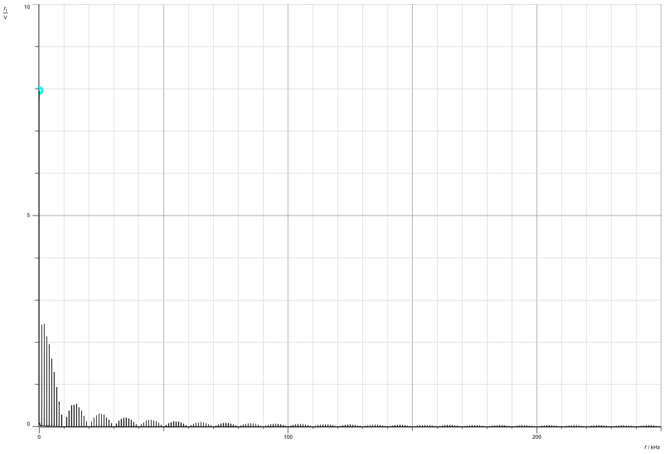

Figure 7: Puls..Train..with..10% Duty Cycle. (In Frequency Domain)

As As depicted in the above figure, the envelope of the pulse spectrum exhibits zero crossings every 10 kHz intervals. This translates to the initial zero crossing transpiring at 10 kHz, followed by subsequent points at 20 kHz, 30 kHz, and onward. The accompanying table illustrates these zero crossings for various duty cycle values. The table below clearly demonstrates that a higher duty cycle corresponds to lower occurrences of zero crossings. This relationship aligns mathematically, as the zero-crossings display an inverse proportionality to the duty cycle, as evidenced in equation-two within the theoretical framework.

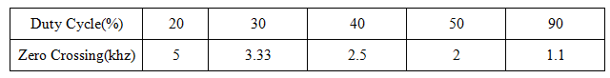

Table1: Zero*Crossings*for*Different*Duty*Cycles

Pulse trains necessitate broader transmission bandwidths to encompass their extensive frequency range. Increased frequency coverage correlates with enhanced transmission accuracy and quality. As illustrated in the aforementioned figure, it's evident that the signal envelope takes on a sinc-shaped form.

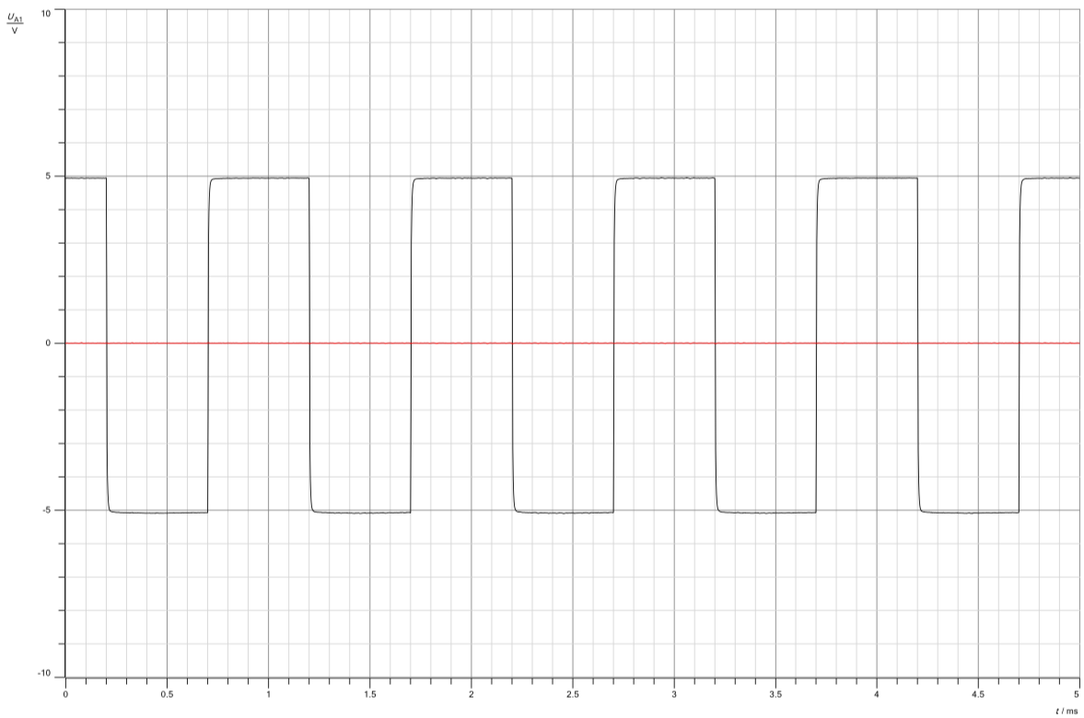

Figure 8: Pulse..Train..with..10% Duty Cycle (In Time Domain)

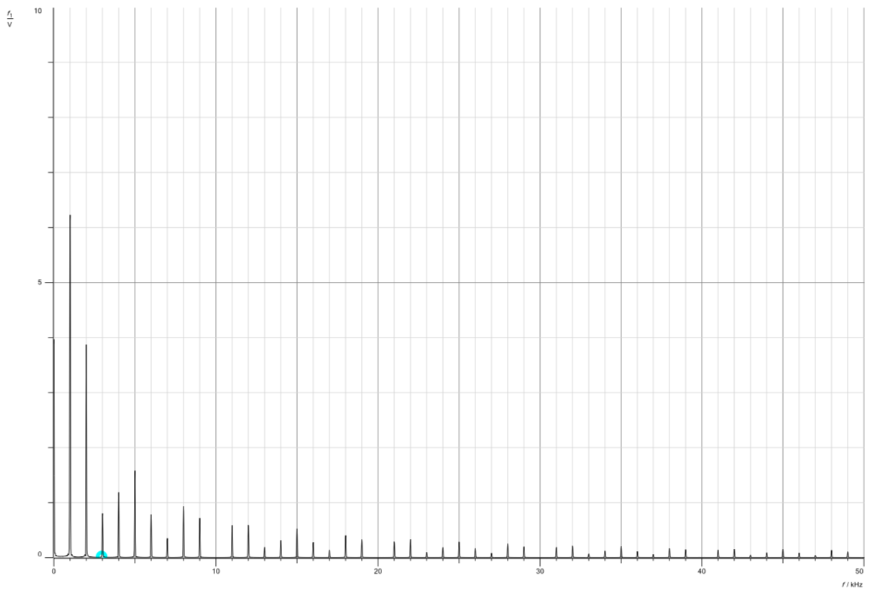

Figure 9: Pulse/Train/with/30% Duty Cycle. (In Frequency Domain).

The figures above demonstrate that altering the duty cycle directly affects the duration the signal spends in the ON-state. A comparison between figures 6 and 8 highlights that a higher duty cycle results in a longer pulse-width. Additionally, examining the frequency domain figures reveals that elevating the duty cycle amplifies the pulses amplitudes.

**3.2 Characteristics of Pulse Amplitude Modulation (PAM).**

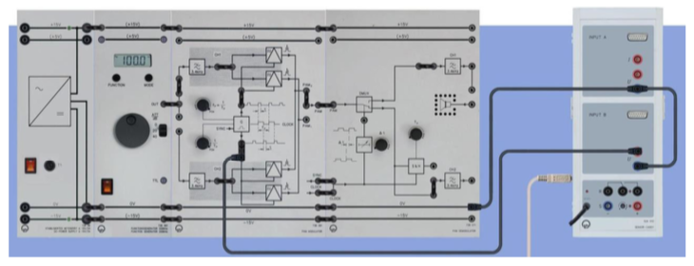

Figure 10: Setup of /Pulse/amplitude/modulation

In this configuration, we maximize both the sampling-frequency-knob and the duty-cycle settings. We link the clock-generator to generate time-samples. By manipulating the pulse frequencies, we set one at 5kHz and then the other at 15kHz, as confirmed by the measurements obtained from the FFT analyzer.

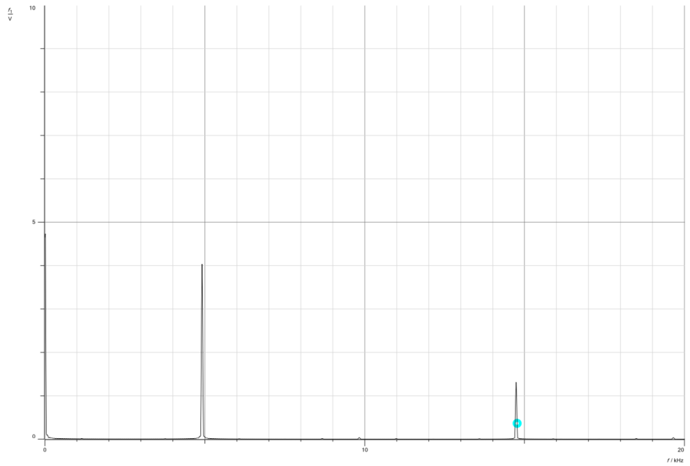

Figure 11: Pulse*frequencies set at/5kHz &/15kHz

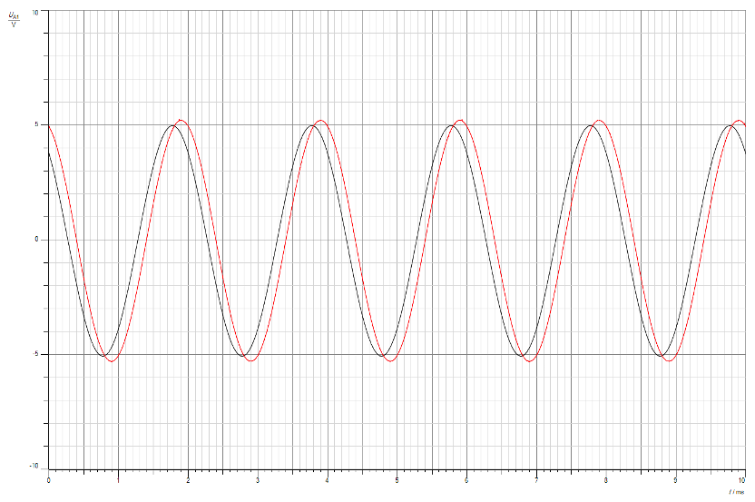

Figure 12: Signal*before*and*after the*channel filter

In this investigation, we examine the impact of the channel filter(CH1). The black-signal represents the state before the filter, while the red signal represents the state after the filter. Observing the results, it is evident that the filter induces a minor shift while maintaining consistent amplitude and frequency.

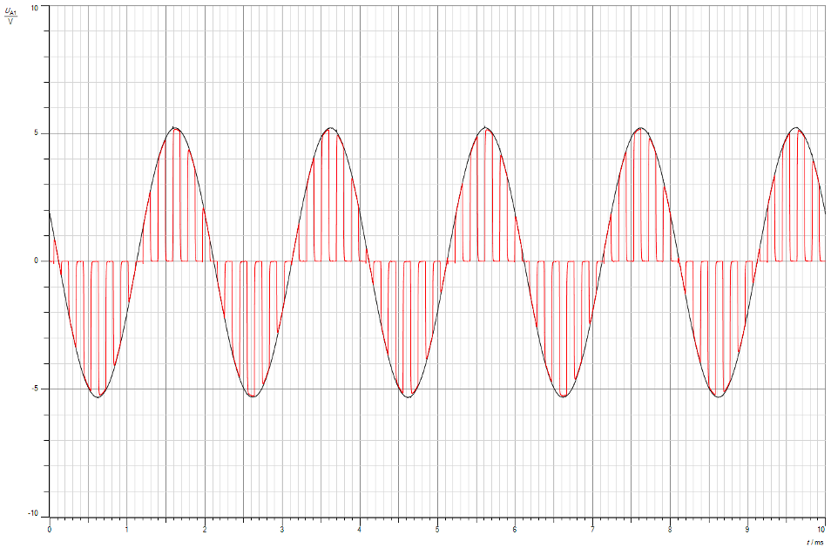

Figure 13: Signal of Pulse amplitude modulated(PAM)

In the above figure, The sampling method observed here appears to be natural sampling, evident from the sampled signals' amplitudes aligning with the signal's amplitude. While ideal or instantaneous sampling is optimal, it's unachievable in practice due to its theoretical nature. Consequently, our lab employs both natural and flat-topped sampling methods to address the limitations of real-world applications.

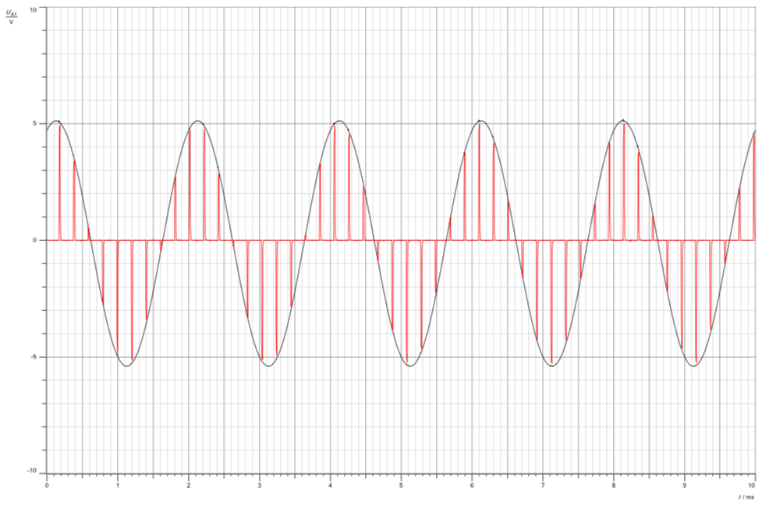

Figure 14: PAM/signal/with/minimum/duty/cycle

Figure 12 and Figure 13 offer a comparison illustrating the impact of the duty cycle on the sampled signal. Decreasing the duty cycle visibly reduces the pulse width within the sampled signal, showcasing a direct correlation between the duty cycle and the resulting pulse width.

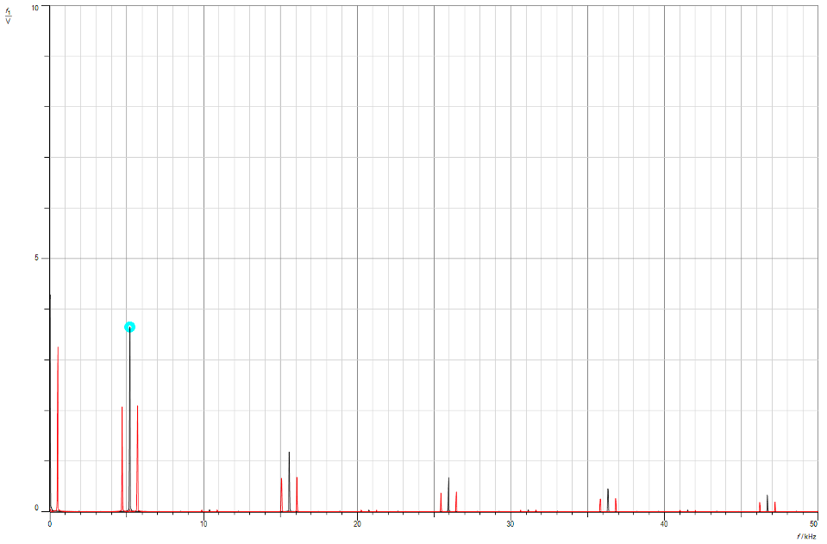

Figure 15: PAM1.output.and.clock.generator

From the figure above, the observed sequence showcases the message signal at 5 kHz, followed by 15 kHz, and then 25 kHz, with a marginal variance in pulse frequency between each transition.

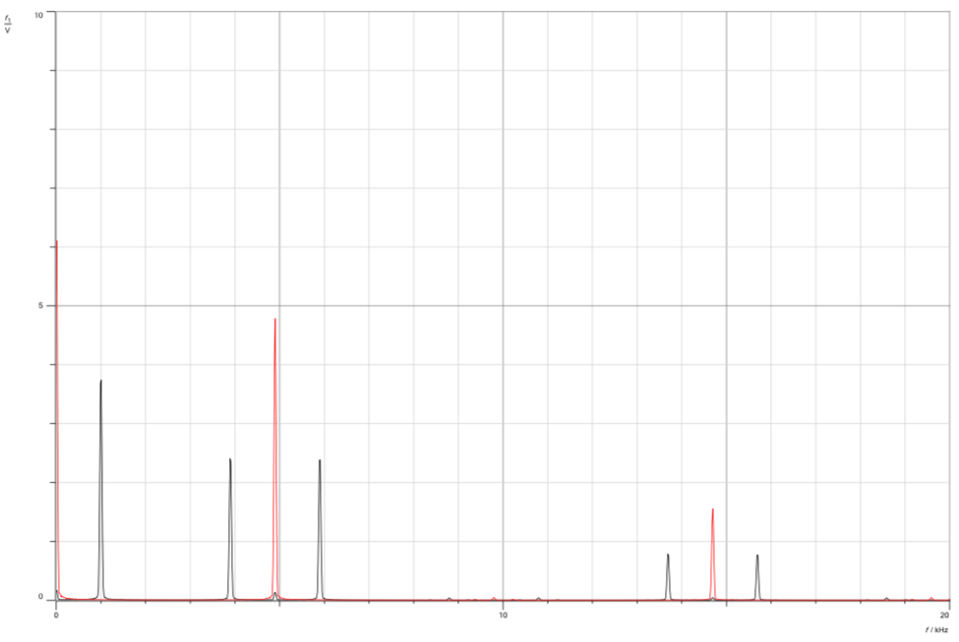

Figure 16: Message*signal/with/frequency = 1khz

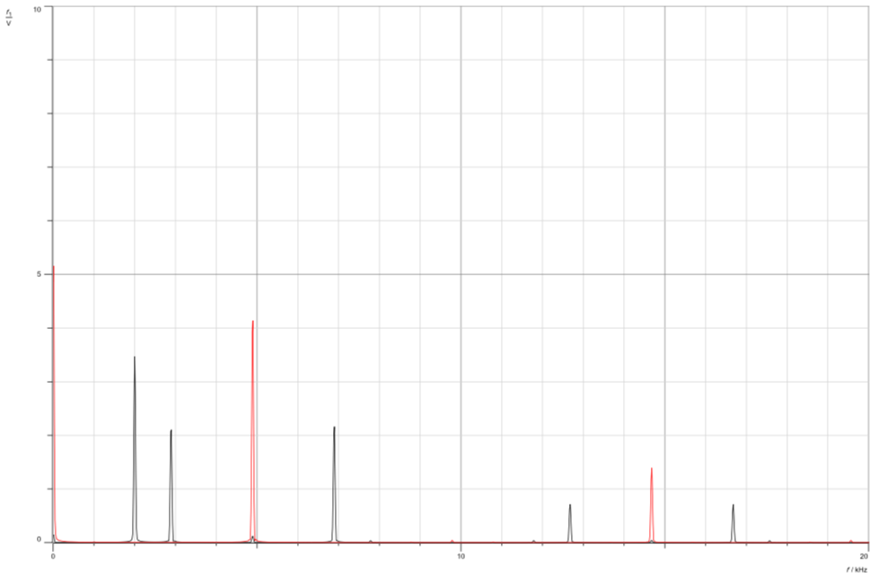

Figure 17: Message/signal/with/frequency= 2khz

Changing The alterations in the message signal frequency are evident in the frequency domain representation. Zero crossings are contingent on both the the duty cycle and the message frequency, exhibiting an increase when the message frequency rises. Additionally, the absence of any interfering signals in the depicted figures indicates the absence of aliasing in the message signals.

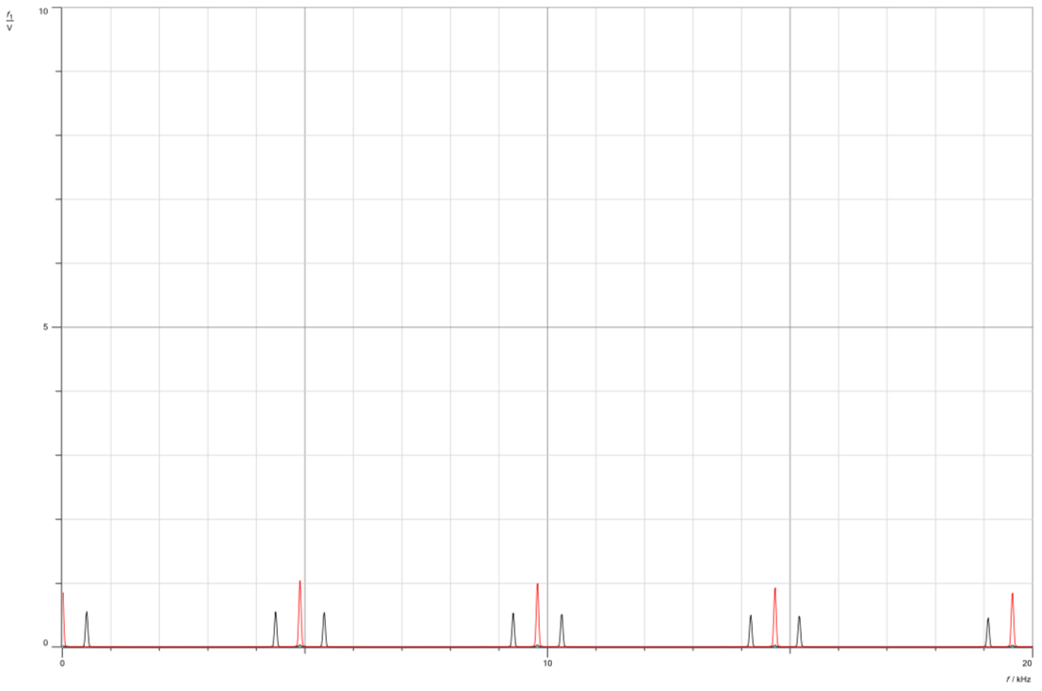

Figure 18: MessageJsignalKwithKDutyKCycle: 10%

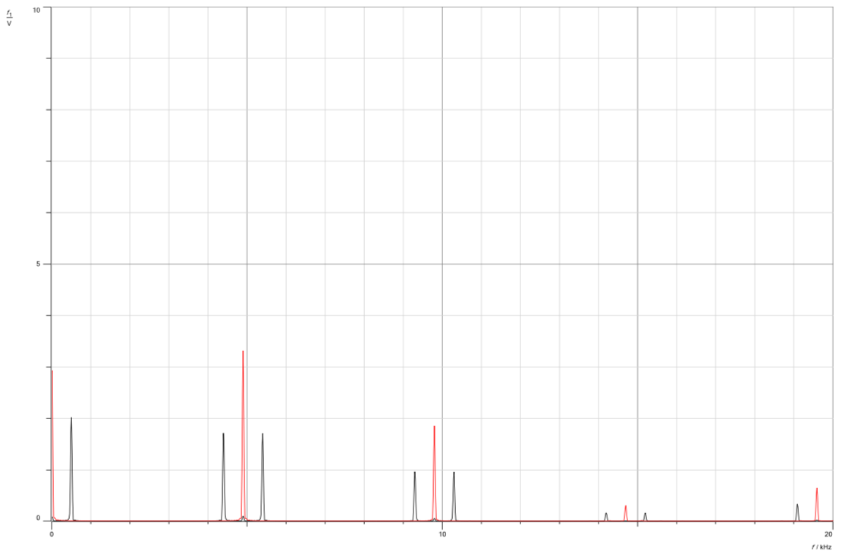

Figure 19: MessagehsignalmwithjDutykCycle 30%

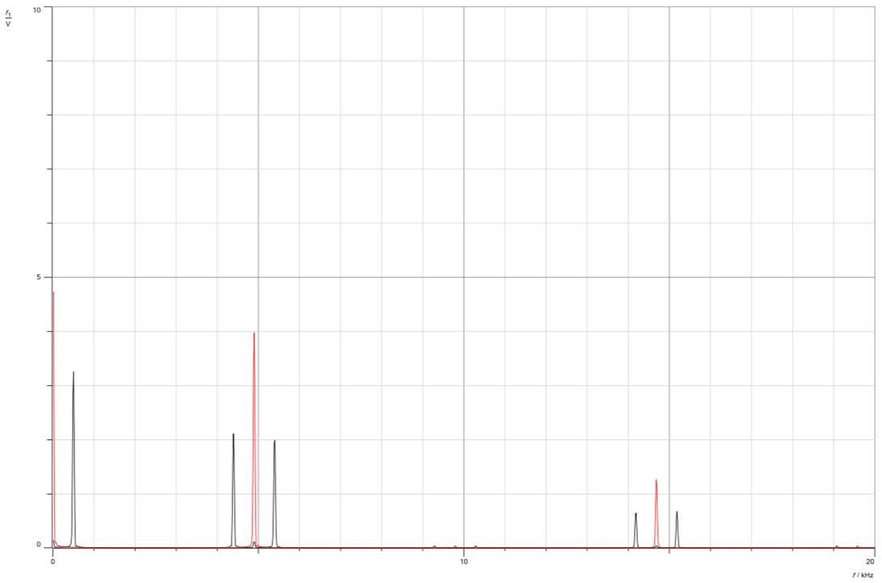

Figure 20: Message*signal*with*Duty*Cycle 50%

Based on the presented figures, it is apparent that varying the duty cycle results in changes to the amplitude of the signals. The progression from a 10% duty cycle to 30% and then to 50% demonstrates a corresponding increase in amplitude.

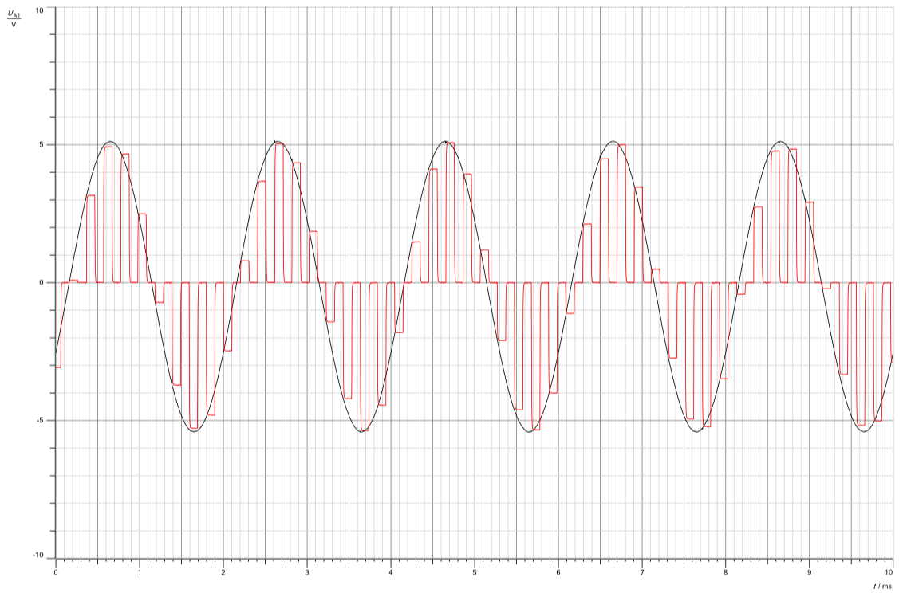

Figure 21: PAM2,modulated,signal,with,max,duty,cycle.

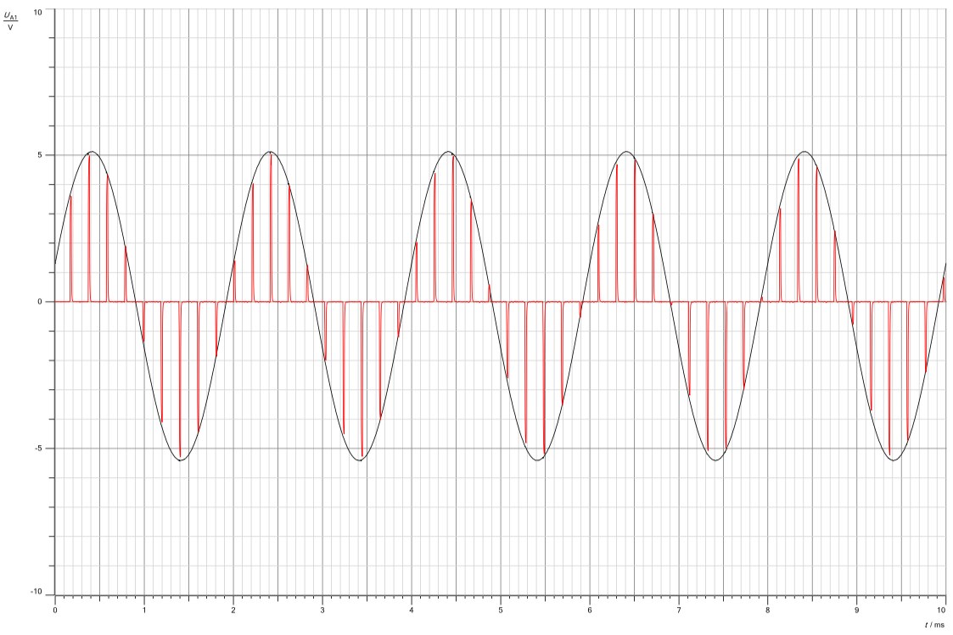

Figure 22: PAM2/with/minimum/duty/cycle.

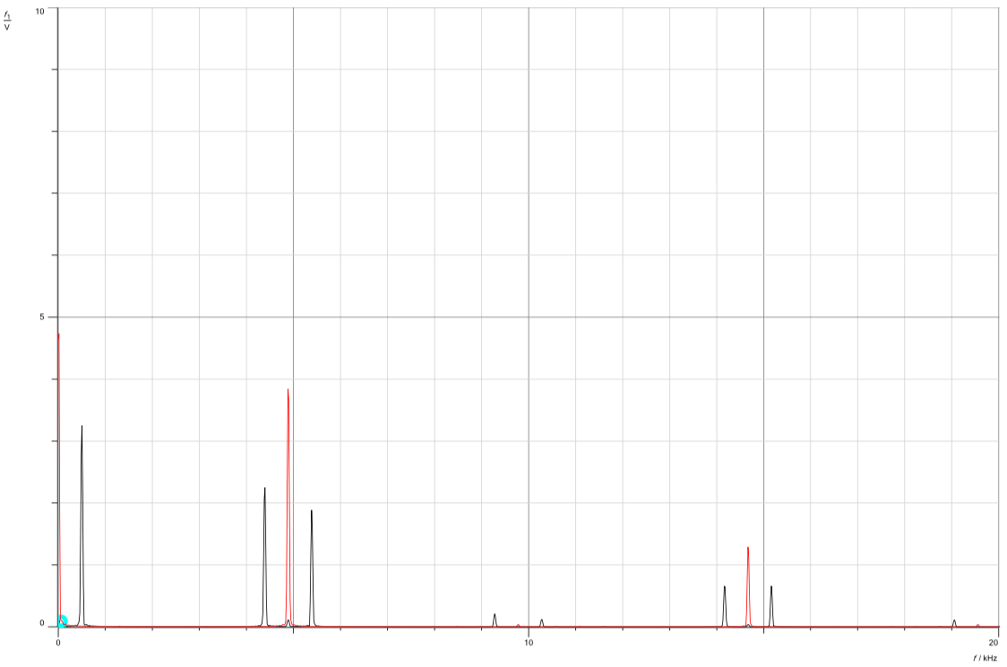

Figure 23: PAM2/with/maximum/duty/cycle/in/frequency/domain.

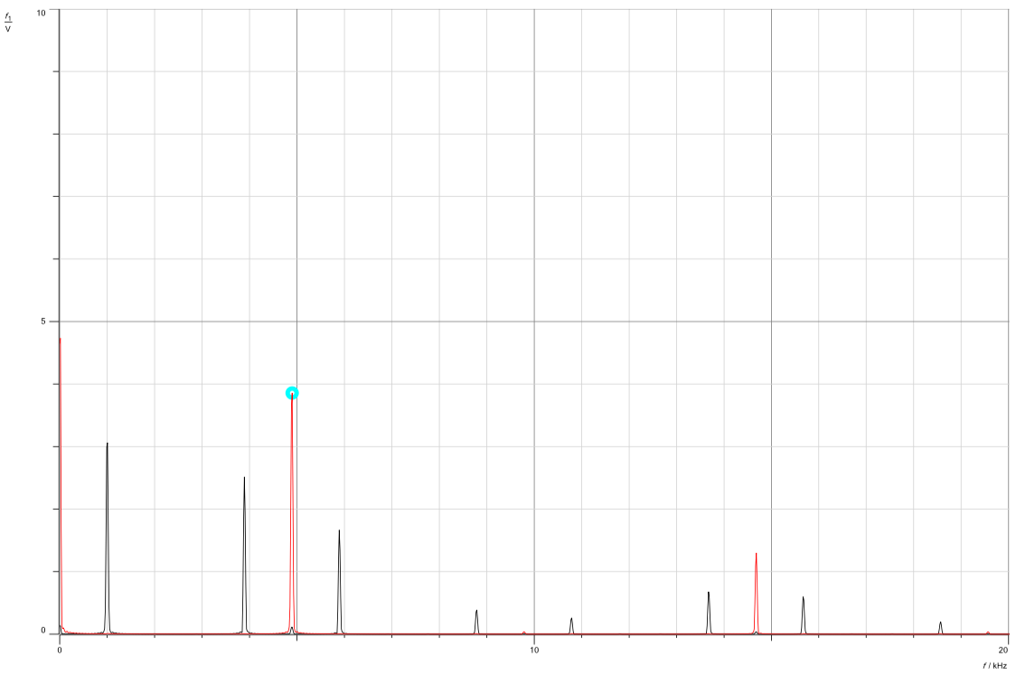

Figure 24: PAM2*signal.with.message.frequency= 1khz

.

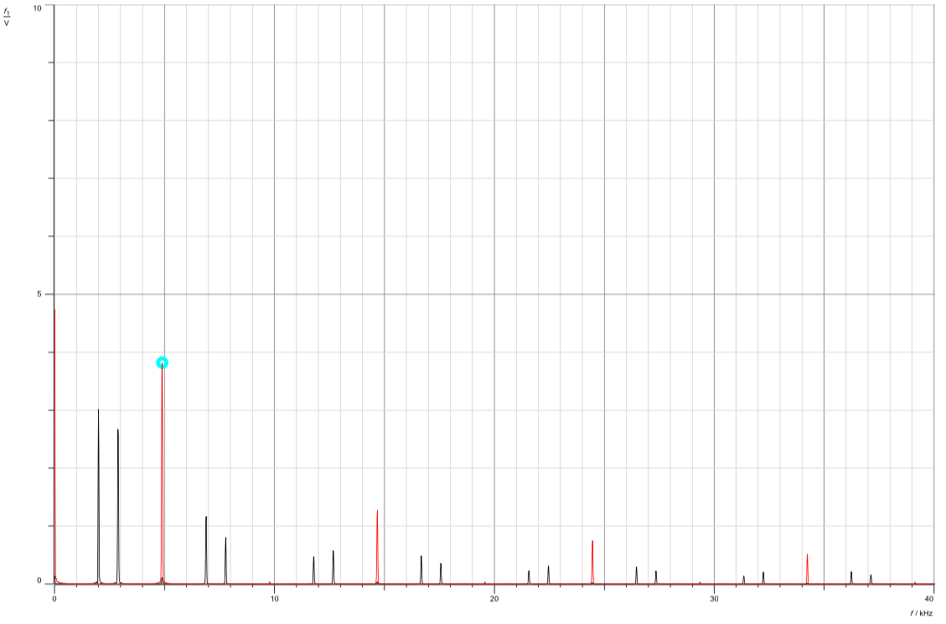

Figure 25: PAM2*signalcwith1message2frequency = 2khz.

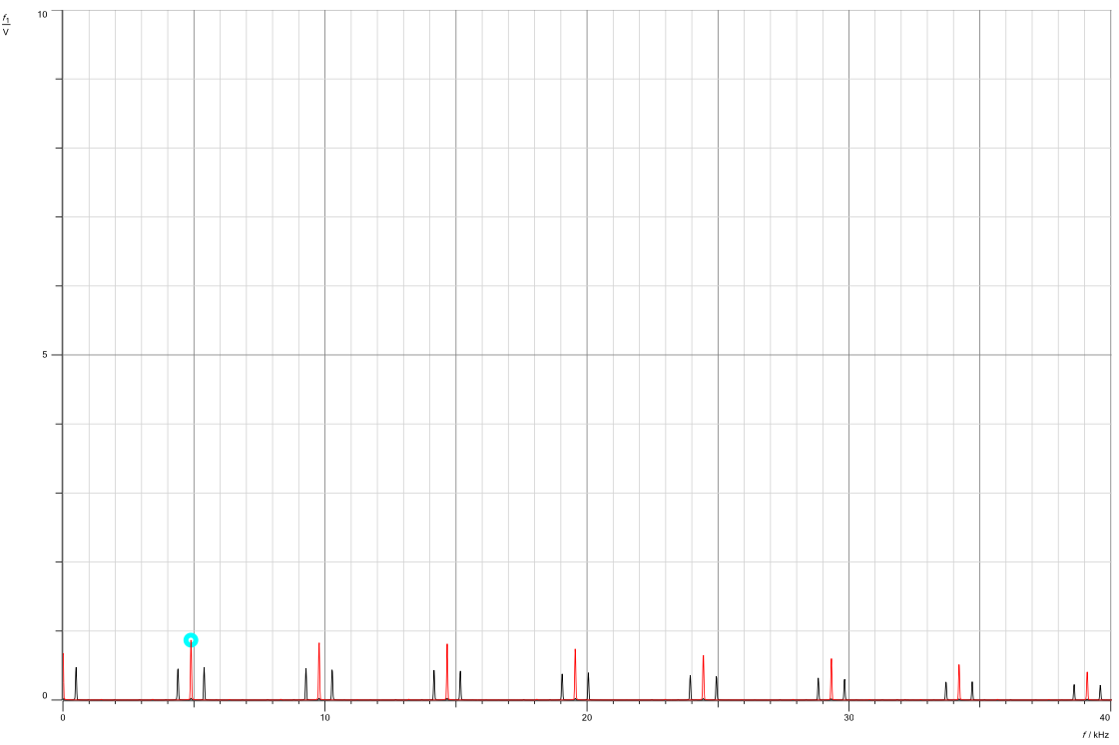

Figure 26: PAM2*with-duty-cycle 10% & fm= 500hz.

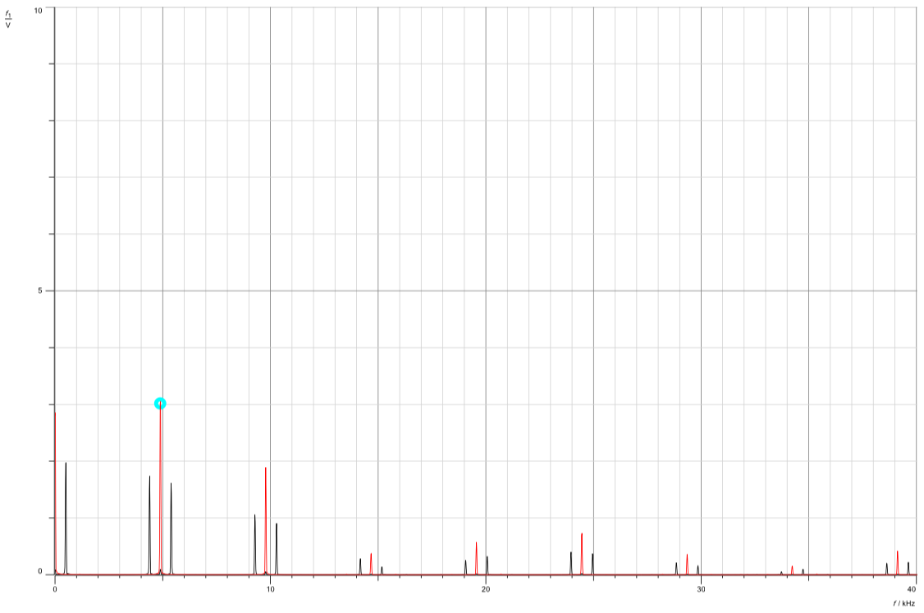

Figure 27: PAM2*with-dutygcycle= 30% & fm= 500hz.

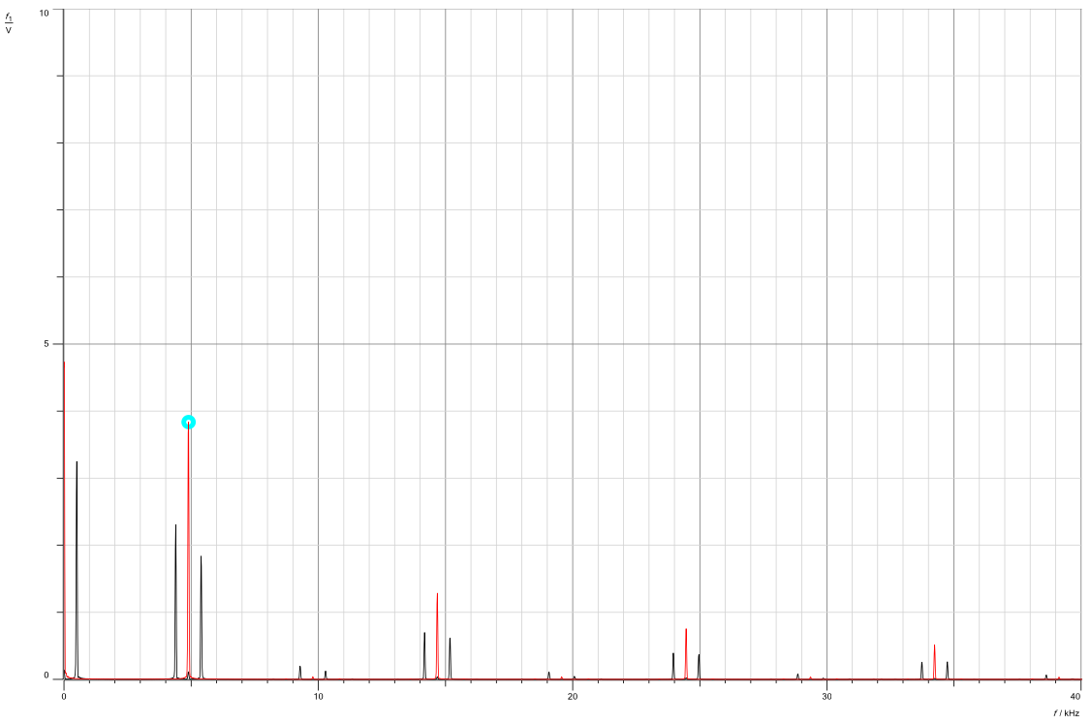

Figure 28: PAM2*with/duty/cycle= 50% & fm= 500hz.

The comparison between PAM1 and PAM2 in the presented figures highlights their distinctions: PAM1 employs natural sampling, whereas PAM2 utilizes flat-top sampling. Despite this difference, both sampling methods exhibit a consistent impact from the message, duty-cycle and frequency. Notably, the figures illustrate that as the duty-cycle rises, the zero-crossings decrease, regardless of whether it's in natural or flat-topped sampling. Furthermore, variations in the frequency of the message signal directly influence the magnitude of zero-crossings. A higher frequency within the message signal results in larger zero-crossings. Equation2 in the theoretical section also underscores this relationship.

Ideal sampling relies on an impulse as a clock generator to enable infinite sampling, deviating from the conventional ON and OFF switch mechanism. However, implementing this concept is unattainable in practical scenarios due to real-world limitations. As depicted in the figures, the observed sampling methods utilized are flat-top and natural sampling, being more feasible options given the constraints of reality.

**3.3 Characteristics of Pulse Amplitude Demodulation.**

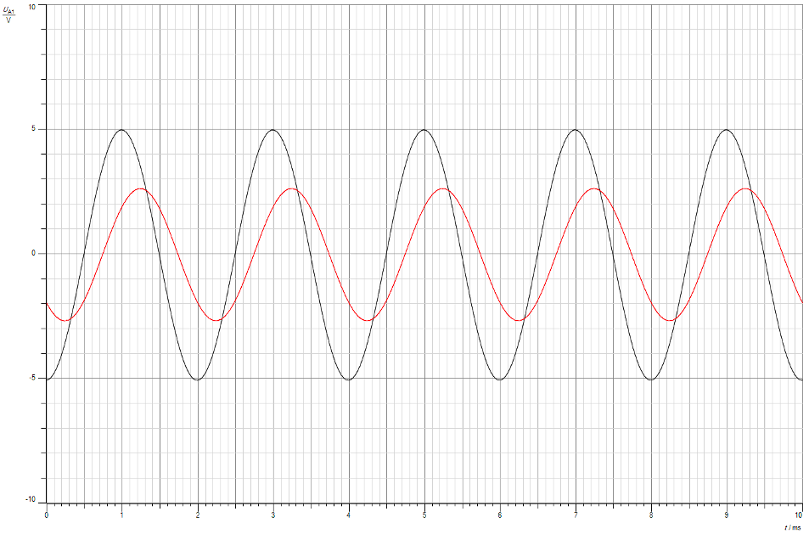

Figure 29: Demodulated signal

In the figure above, the black-signal represents the message signal, whereas the red-signal represents the demodulated signal. Notably, the demodulated signal effectively recovers the message signal, albeit with a varied amplitude. This discrepancy is anticipated due to the inherent gain factors associated with filters in the demodulation process.

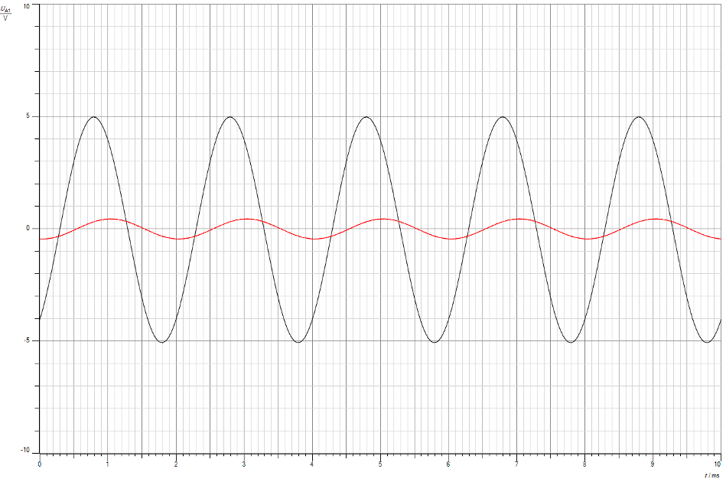

Figure 30: Demodulated signal with 10% duty cycle.

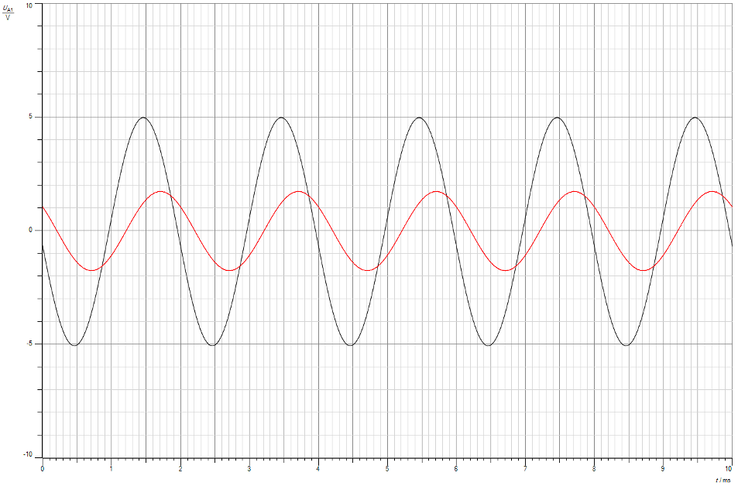

Figure 31: Demodulated signal with 30% duty cycle.

The figures above a clear relationship between the duty cycle variation and the resulting amplitude within the demodulated signal. With an increase in the duty cycle, there is a corresponding rise in the demodulated signal's amplitude.

**3.4 Aliasing in the Time and the Frequency Domain.**

Initially, we configure the clock generator frequency at 5 kHz with a 50% duty cycle. and the function generator is set to the following: Sine wave, Freq = 3000hz, and Vss=5v. Then we connect the UA1 to the output signal of channel 1 filter, and UB1 to the PAM1 modulator. Finally, we place UB1 to the output of the demodulator filter of CH1.

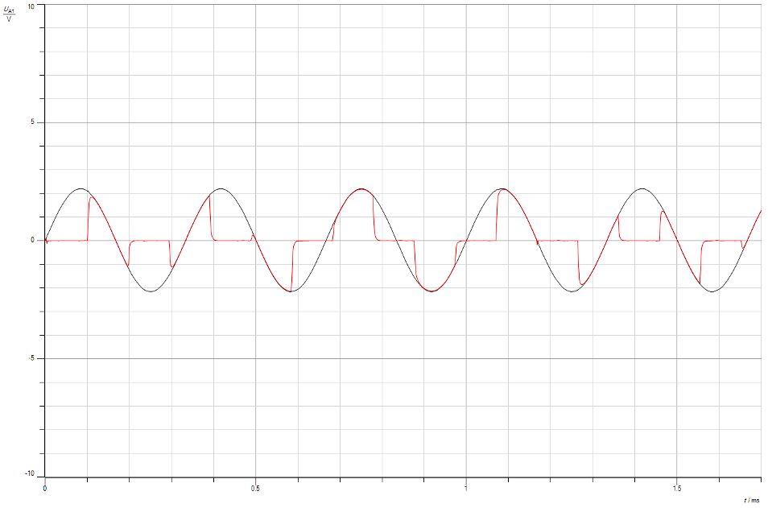

Figure 32: Signal with PAM1*modulator.

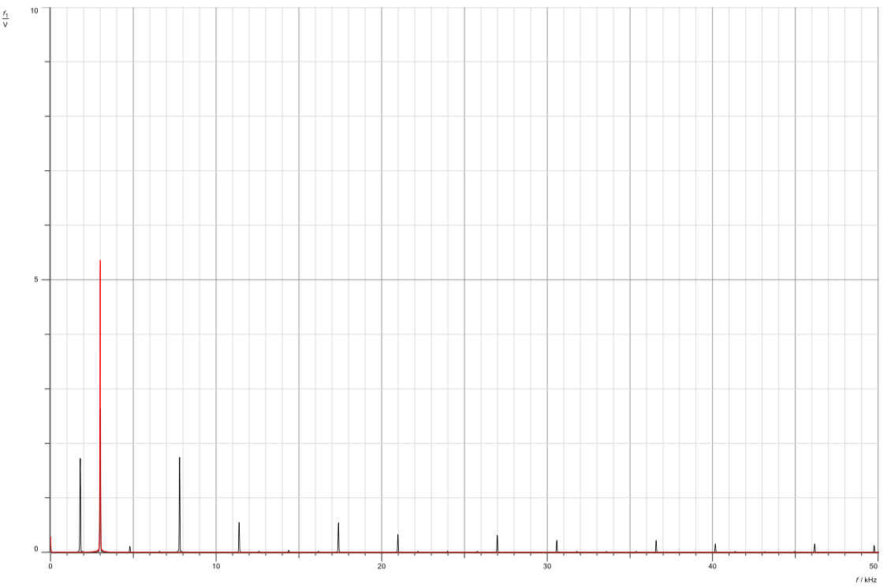

Figure 33: Signal/with/Aliasing

As shown in the figure, the message signal, indicated in red, operates at a 3kHz frequency. Notably, an additional impulse is discernible around~2kHz within the same space. This occurrence signifies aliasing, a result of the sampling frequency being lower than twice the message frequency. As previously discussed, adhering to the Nyquist rate is crucial to prevent aliasing in such scenarios.

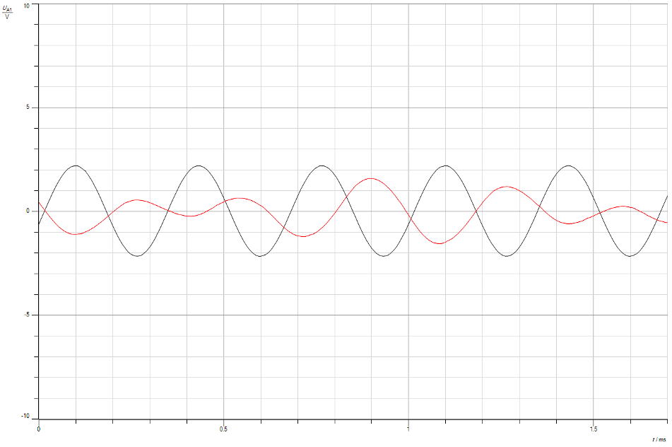

Figure 34: Signal/with/demodulator/filter of CH1

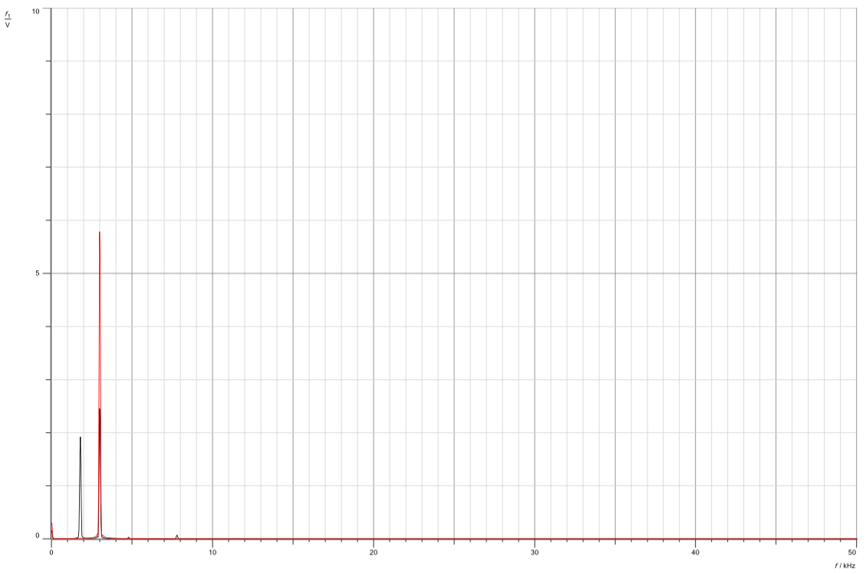

Figure 35: Demodulated signal in frequency domain

In this scenario, the message signal maintains a 3kHz frequency, and the demodulated signal indeed aligns with that frequency. Despite this alignment, the presence of aliasing indicates an inaccurate retrieval of the signal, leading to deviations and inconsistencies.

**3.5 PAM Time Multiplex**.

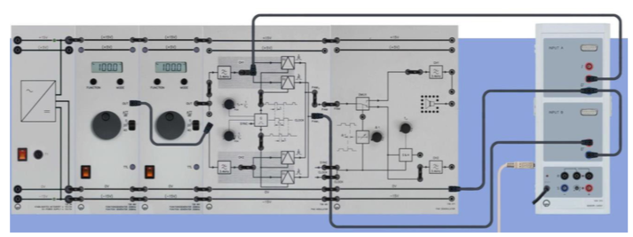

Figure 36: PAM,Time,Multiplex*Setup

In this configuration, it's essential to maximize the sampling frequency (fp) and duty cycle settings. Additionally, the function generator settings should be adjusted as follows: Set to Sine wave, with a frequency (fM2) of 300 Hz, and a VSS (voltage) of 10V.

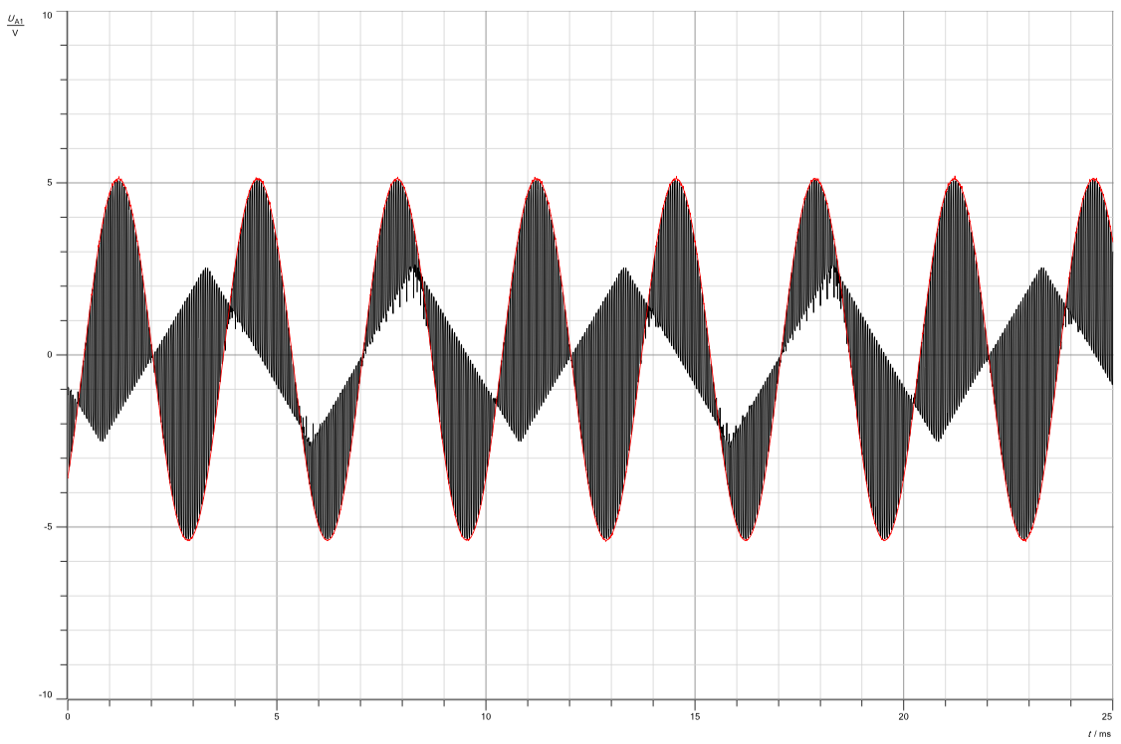

Figure 37: Triangular,message,channel,CH1

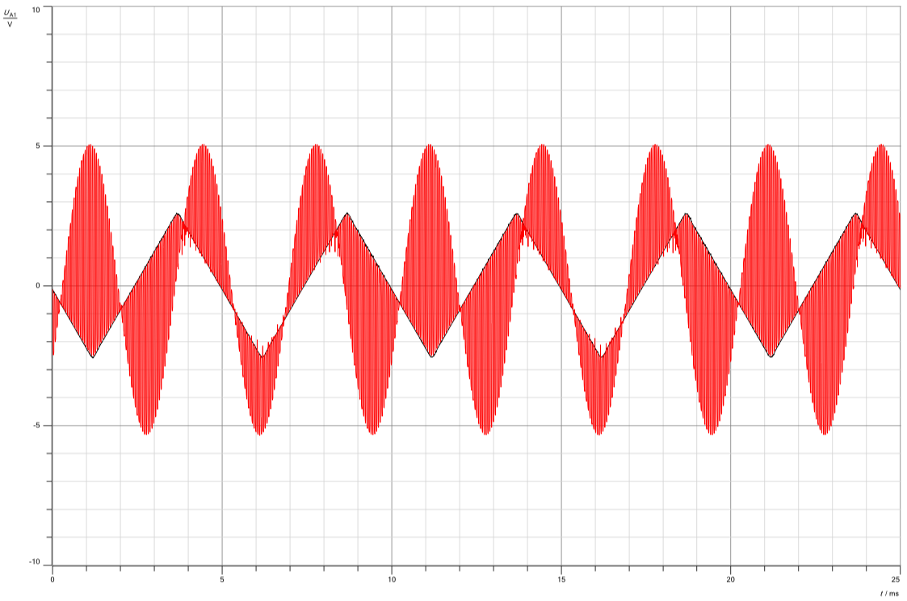

Figure 38: Sine.message channel CH1

Here we can see two signals on the same time domain. One is triangular and the other is sinusoidal. Now we set the function generator to Triangle, Fm1=200hz, and Vss = 10V. The second function generator is set to Sine, Fm2=300hz, and Vss=10.

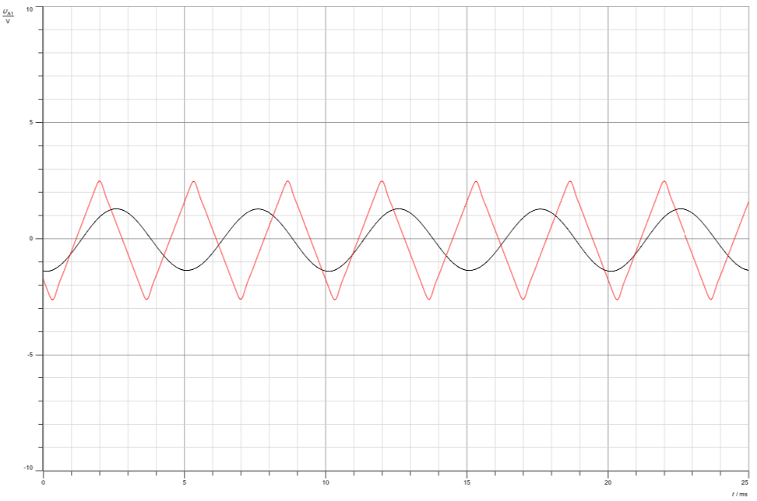

Figure 39: Demodulated Signals

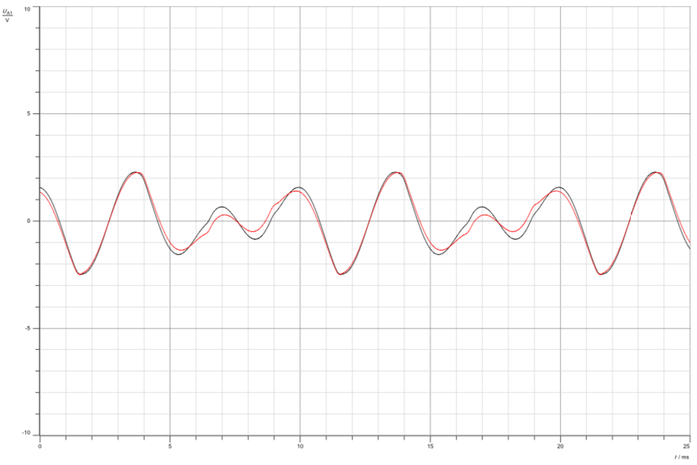

Figure 40: Effect.of.delta .(middle)

Here In this observation, two signals —triangular and sinusoidal— are depicted within the same time-domain. The settings for the function generators are adjusted as follows: The first function generator is configured for a triangular waveform with a frequency (Fm1) of 200Hz and a voltage (Vss) of 10V. Meanwhile, the second function generator is set to produce a sinusoidal waveform with a frequency (Fm2) of 300Hz, and a voltage (Vss) of 10V.

**Conclusion**

In this lab, pulse amplitude modulation (sampling) and demodulation, as well as, aliasing effect, time multiplex and cross talk were covered. The modulation process in both the time and frequency domains were discussed;specifically, the effect of the duty cycle and message frequency on the Pulse amplitude modulated signal. We have learned about the different types of sampling techniques, which are neutral, ideal and flat-topped sampling. We have also discussed the difference between practical implementations and theoretical implementations.

# 

# 

# **References**

[1]:<https://en.wikipedia.org/wiki/Pulse-amplitude_modulation>

[2]:<https://www.icrfq.net/pulse-amplitude-modulation/>jjjjjjjjjjjjjj hhhhhhhhhhhhhhhhhhhhhhh

[3]:<https://www.tutorialspoint.com/signals_and_systems/signals_sampling_techniques.htm>jjjjjjjj

[4]:<https://electronicscoach.com/time-division-multiplexing.html>kkkkkkkkkkk

[5]:<https://www.analog.com/media/en/technical-documentation/application-notes/an-282.pdf>jjjjjj

[6]:<https://dsp.stackexchange.com/questions/36436/whats-the-impact-of-aliasing-in-the-time-domain>

[7]: <https://www.sciencedirect.com/topics/engineering/pulse-frequency>

[8]:<https://en.wikipedia.org/wiki/Pulse_wave>